**Integrating the Healthcare Enterprise**



**IHE Patient Care Coordination**

**Technical Framework Supplement**

**Cross Enterprise Basic eReferral**

**Workflow Definition Profile**

**(XBeR-WD)**

**Trial Implementation**

Date: October 4, 2013

Author: IHE PCC Technical Committee

Email: pcc@ihe.net**Foreword**

This is a supplement to the IHE Patient Care Coordination Technical Framework V9.0. Each supplement undergoes a process of public comment and trial implementation before being incorporated into the volumes of the Technical Frameworks.

This supplement is published on October 4, 2013 for Trial Implementation and may be available for testing at subsequent IHE Connectathons. The supplement may be amended based on the results of testing. Following successful testing it will be incorporated into the Patient Care Coordination Technical Framework. Comments are invited and may be submitted at [http://www.ihe.net/PCC_Public_Comments](http://www.ihe.net/PCC_Public_Comments/).

This supplement describes changes to the existing technical framework documents.

“Boxed” instructions like the sample below indicate to the Volume Editor how to integrate the relevant section(s) into the relevant Technical Framework volume.

Amend section X.X by the following:

Where the amendment adds text, make the added text bold underline. Where the amendment removes text, make the removed text bold strikethrough. When entire new sections are added, introduce with editor’s instructions to “add new text” or similar, which for readability are not bolded or underlined.

General information about IHE can be found at: [www.ihe.net](http://www.ihe.net).

Information about the IHE Patient Care Coordination domain can be found at: [http://www.ihe.net/IHE_Domains](http://www.ihe.net/IHE_Domains/).

Information about the organization of IHE Technical Frameworks and Supplements and the process used to create them can be found at: [http://www.ihe.net/IHE_Process](http://www.ihe.net/IHE_Process/) and [http://www.ihe.net/Profiles](http://www.ihe.net/Profiles/).

The current version of the IHE Patient Care Coordination Technical Framework can be found at: [http://www.ihe.net/Technical_Frameworks](http://www.ihe.net/Technical_Frameworks/).

**CONTENTS**

Introduction to this Supplement 4

Open Issues and Questions 4

Closed Issues 4

**Volume 1 – Profiles 6**

X XBeR-WD Profile 6

X.1 Purpose and Scope 6

X.2 Process Flow 7

X.3 Workflow Participants and Process Flow 9

X.3.1 Use Cases 10

X.3.1.1 Basic process flow 11

X.3.1.2 Failing situations 15

X.3.2 Options 24

X.3.2.1 Process without Scheduling phase 24

X.3.2.2 Reminder Note Option 24

X.4 Workflow Definition Actors and Options 25

X.4.1 Workflow Definition Actors 25

X.4.2 Workflow Options 25

X.4.3 Workflow Definition Profile Grouping with other Profiles 26

X.5 Security Considerations 27

**Volume 2 – Content Modules 28**

Y.1 XBeR Workflow Definition - XDW Workflow Document – Common Attributes 28

Y.2 XDW Content Modules 29

Y.3 Tasks Specifications 30

Y.3.1 Task: “Request Referral” 31

Y.3.2 Task: “Schedule Referral” 32

Y.3.3 Task: “Perform Referral” 33

Y.4 Input and output documents 35

Appendix A - Complete example of eReferral Workflow Document 36

Appendix B - Technical development of WD related to the eReferral process 41

B.1 Management of the “Failing of Scheduling” 41

B.2 Management of the “Failing of the reception” phase 43

B.3 Management of the “Failing of the visit” 44

# Introduction to this Supplement

This supplement is written according to the specific template defined for Workflow Definition profiles. The structure of this document differs from a PCC Content Profile. In particular the XBeR-WD profile establishes a common set of rules to share between participants involved in an eReferral workflow.

The eReferral process, and workflow related to it, is applicable to many different sharing infrastructures. In this profile we present a specific XDS based use-case.

In Volume 1 we present a typical Use-case, describing many possible evolutions of the related workflow. We define the Workflow Participants involved and their ability within the workflow itself.

In Volume 2 we explain how to use an instrument the XDW Workflow Document (See ITI Technical Framework and supplements) to track and manage this workflow. In particular, we analyze in detail features of each step of the workflow, and rules to follow to go through these steps.

At the end of the supplement (Appendix A) is presented a complete example of a Workflow Document produced during an eReferral workflow.

More technical details related to the management of the workflow document are presented in the Appendix B.

## Open Issues and Questions

None

## Closed Issues

* *(Reviewers should evaluate the need to define options within the Workflow Definition to facilitate implementation of the workflow definition profile. Should there be options on the (1) support of specific workflow tasks/status, (2) reference content document profiles, (3) remaining options from XDW? These would be formalized and placed in Section X.4 Option of Volume 1. The requirements for support of options related to the XDW Profile may not be properly placed in Section X.4 and should be moved to Volume 2.)* Answer: The workflow Definition profile defines a section Options where are described alternative paths, or alternative rules for the evolution of the process.
* *(Reviewers should evaluate the proposed table in Section 6.5 that describes the documents created during the workflow process, their requirements, their nature and their related PCC(or other) document content profiles that define them and, in case that these are not present, the note that the PCC may/should define them in the future. How specific should a workflow definition profile be in terms of referenced documents conformance requirements?)* The Workflow Definition profile defines only “documents labels” to define the role of an attachment of the profile.
* *(In many parts of this document we present XML examples to better understand how the Workflow Document can track information related to the process. This structure will be affected by CPs proposed to the ITI domain (CP-643, CP-637). So these XML parts may change sections X.2.1.1, X.2.2.1, X.2.3.1 and Appendix A)* Small xml parts are removed from text, we left only the appendix A to show a complete example of Workflow Document.

Volume 1 – Profiles

# X XBeR-WD Profile

The Cross Enterprise Basic eReferral Workflow Definition profile builds upon the ITI Cross Enterprise Document Workflow (XDW) profile to manage the workflow related to an eReferral.

The management of the workflow related to clinical processes is a critical complement to the use by different sectors of document sharing related IHE profiles with their different types of document and information. IHE ITI has approved in Trial Implementation the Cross-Enterprise Document Workflow profile but the work done by ITI has been on the definition of the technical infrastructure to manage a clinical workflow and not on the definition of the clinical processes, work left to the different IHE Domains.

The Cross Enterprise Basic eReferral Workflow Definition Profile defines the workflow related to the eReferral. This workflow is involved in many clinical and organizational processes for its important role in the process of digitalization. The definition of a workflow with fixed rules and tasks is needed in a cross enterprise scenario in which many participants are involved to support a referral process

## X.1 Purpose and Scope

Cross-enterprise management of the workflow related to clinical processes is a fundamental topic with the increasing use by different sectors of document sharing related IHE profiles with their different types of document and information.

This profile is built upon the ITI XDW Profile to manage the Cross Enterprise Basic eReferral Workflow. The management of the workflow related to the eReferral is involved in many clinical and organizational processes for its important role in the process of digitalization. The lack of a workflow management, at the moment, blocks the use of the eReferral in an extended way. The eReferral, without an instrument to manage its workflow, is only an order without any information about the status of the order itself. The definition of a workflow with fixed rules and tasks is needed in a cross-enterprise scenario in which many actors are involved in the same process.

The creation of an eReferral by a GP, or Primary Care Provider (PCP) opens a clinical process that involves many actors and that is a cross-enterprise workflow. The purpose of the XBeR-WD profile is to precisely define the workflow associated with an eReferral Document, the actors involved and the digital documents related with this process (produced in this or in other processes, but related to the eReferral workflow).

## X.2 Process Flow

A common workflow pathway that illustrates the simplest process enabled by XBeR-WD profile is the use-case where the patient consults his GP for a health problem. As part of the consultation the patient is examined and some prior information is looked up by the GP. As a result of the visit the GP refers the patient to a specialist for further examination.

The workflow connected to these organizational and clinical actions is composed of four steps:

1. a physician refers a patient to another healthcare provider for a specialist’s consultation;
2. the Health Care Provider (HCP), from the Hospital Information System, schedules the visit;
3. the HIS admits the patient in hospital and the specialist can start the consultation which may span one or more visits;
4. the specialist completes the consultation and produces a report;

These steps can be modeled in 3 different tasks of the eReferral workflow, (figure X.2-1):

1. Request Referral: that tracks step A, performed by the Requester of the referral
2. Schedule Referral: that tracks step B, performed by the Scheduler of the visit (This task is optional and doesn’t need to be tracked if the option “Process without scheduling phase” is selected)
3. Perform Referral: that tracks steps C and D, performed by the HCP and the specialist.



Figure X.2-1: Tasks involved in the eReferral process

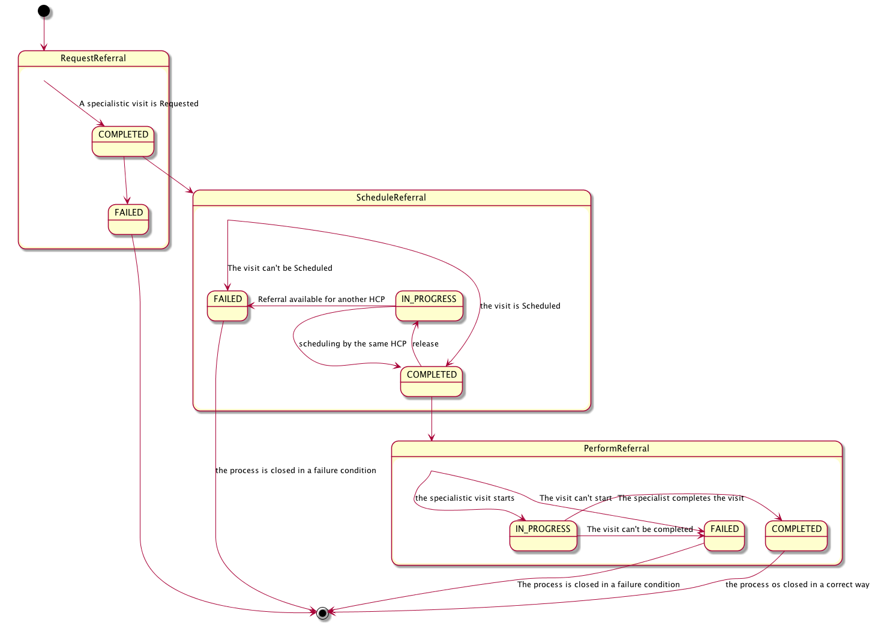

Figure X.2-2: XBeR Workflow Definition complete process flow

The following table (table X.2-1) lists the various documents that shall, or may be referenced as either input or output documents for each task/status pair defined by the XBeR-WD profile.

Table X.2-1: Documents referenced for each task/status pair

| Task Name | Task Status | Input Docs | Option | Output Docs | Option |
| --- | --- | --- | --- | --- | --- |
| Request Referral | COMPLETED | Clinical input | O | eReferral | R |
| IN_PROGRESS | N/A | - | N/A | - |
| FAILED | N/A | - | Exception Report | R |
| Schedule Referral | COMPLETED | eReferral | R | Reminder Note | O * These may change if Workflow Options are selected |
| IN_PROGRESS | N/A | - | N/A | - |
| FAILED | N/A | - | Exception Report | C: if the visit can’t be scheduled |
| Perform Referral | IN_PROGRESS | eReferral | R | N/A | - |
| COMPLETED | eReferral | R | Clinical Report of the visit | R |
| FAILED | N/A | - | Exception Report | R |

## X.3 Workflow Participants and Process Flow

In this section we present the Workflow Participants involved in the eReferral process and, using the figure X.3-1, we describe in detail process transactions and interactions between them.

A Workflow Participant is an abstraction of system along with users involved in the eReferral process. They can be identified, based on their roles in the process, as one of four specific participants. Each of these workflow participants has specific rights and duties in the process. They drive the process from one step to another, performing determinate actions on the workflow.

|  |  |
| --- | --- |
| Workflow  Participants | Description |
| Referral Requester | *Health Professional (e.g., GP) that initiates the referral workflow. Produces the eReferral and the related supporting document.* |
| Referral Scheduler | *Participant responsible for the scheduling of the referral, by providing an appointment for the patient* |
| Referral Performer | *Participant responsible for execution of the visit. This workflow participant encapsulate many entities within the enterprise that responds to the referral request and produce the clinical report of the visit ending the eReferral process* |
| Workflow Monitor | *Participant that tracks progress of the workflow and reacts to certain exception conditions. This participant can be standalone or grouped with one of the above Workflow Participants* |



Figure X.3-1: Process transaction between Workflow Participants

### X.3.1 Use Cases

Mr. Rossi has a terrible head-ache and goes to his GP Dr. Smith to have a consultation. Dr. Smith analyzes the clinical history of the patient and sees that this is a frequent symptom for Mr. Rossi. Dr. Smith cannot understand the reason for this health problem, so decides to refer his patient to another specialist. Mr. Rossi choses Dr. Bianchi as the specialist to perform the consultation and schedules a visit. On the day of the visit, Dr. Bianchi studies the reports that have been sent with the eReferral by Dr. Smith, performs the visit and produces a Report for the GP. Mr. Rossi returns to Dr. Smith’s office, who analyzes the report and decides to prescribe a drug for the patient.

In this section we present the detailed use-case of reference. In the first part of this section (subsection X.3.1.1) we present the detailed chronological sequence of steps involved in the simplest process flow, without failing situations or scheduling cancellation. In the second one (subsection X.3.1.2) we present potential exception situations and the scheduling cancellation phase.

#### X.3.1.1 Basic process flow

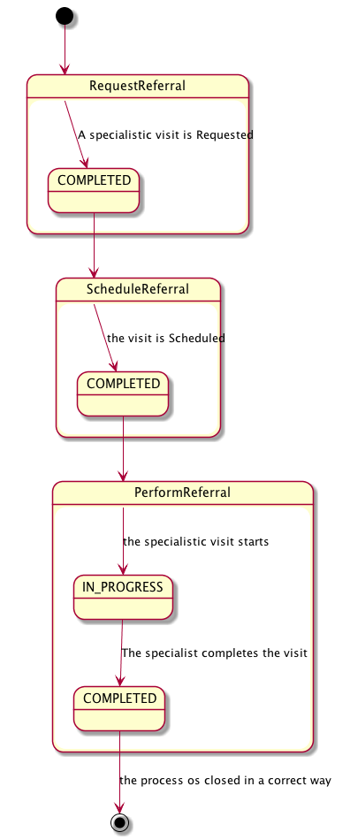

1. **A physician refers a patient to another healthcare provider for a specialist’s consultation**

In this task the GP examines the patient and reviews the patient’s most recent laboratory reports. The GP refers the patient to a specialist, creating an eReferral Document and referencing the laboratory reports.

The GP’s software, as a Referral Requester, produces the eReferral Document and one Workflow Document to track the clinical workflow of the eReferral. As shown in column A of Figure X.3.1.1-1, at this moment the Workflow Document created has only one task (“Request Referral”) characterized by:

* a task status “COMPLETED”
* the references to the laboratory report analyzed by the GP as inputs of the task
* the reference to the eReferral document produced as outputs of the task.

In order to share documents that are produced during the task, the Referral Requester submits the eReferral Document and the Workflow Document to the XDS Document Repository.



Figure X.3.1.1-1: Management of the Workflow Document in a basic process flow

From this moment the eReferral is available to a wide range of care providers.

**B. The HCP, from the Hospital Information System, schedules the visit**

The patient can call or go to healthcare provider of his choice (or suggested by the GP) to schedule the exam.

During this step the HCP, as a Referral Scheduler, checks in which step the eReferral is and he schedules the visit. Once the visit has been scheduled, the Referral Scheduler updates the Workflow Document to track that the visit has been scheduled. As shown in column B of figure X.3.1.1-1, at this step of the workflow, the Workflow Document is updated with a new version in which a new task “Schedule Referral” is added to the content of the previous version of the Workflow Document.

The task “Schedule Referral” is characterized by:

* a task status “COMPLETED”
* the references to the eReferral document produced by the GP as inputs of the task.

The Referral Scheduler provides the updated version of Workflow Document to the XDS Document Repository/Registry through a Replace of the previous version of the Workflow Document. From this moment no other HCP can claim this referral.

**C. The patient is admitted by the HCP the day of the visit and the specialist can start the visit**

The patient is admitted by the HCP on the scheduled day and time. During this task, the HCP, as a Referral Performer, consults the eReferral and the Workflow Document related to understand the task that needs to be performed and the process of the visit can start.

The Referral Performer accesses the document by using his software, and an XDS Document Consumer, to query and retrieve the Workflow Document and the eReferral document, to check the reservation.

As shown in column C of figure X.3.1.1-1, at this step of the workflow, the Workflow Document is updated with a new version in which a new task “Perform Referral” is added to the content of the previous version of the Workflow Document. The task “Perform Referral” is characterized by:

* a task status “IN_PROGRESS”
* the references to the eReferral document produced by the GP as inputs of the task.

The Referral Performer provides the updated version of Workflow Document to the XDS Document Repository/Registry through a Replace of the previous version of the Workflow Document

From now the Workflow Document and the eReferral document are available for the specialist.

**D. The specialist completes the consultation and produces a report**

The specialist performs the visit and, at the end of the consultation the specialist’s software, as a Referral Performer, produces a report of the consultation itself and he terminates the visit process.

In this task, the Referral Performer updates the Workflow Document changing the status of the “Perform Referral” task.

As shown in column D of the figure X.3.1.1-1 the Workflow Document, the “Perform Referral” task is characterized by:

* a task status “COMPLETED”
* the references to the eReferral document produced by the GP (the laboratory report was not used by the specialist) as inputs of the task
* the references to the report of the consultation as output of the task

The history of the changes of status of the task is tracked inside the task as a list called taskEventHistory.

The Referral Performer provides the updated version of Workflow Document to the Document Repository through a replace of the previous version of the Workflow Document

At any time the Referral Requester may review the Workflow Document and the new documents produced related to this workflow. This is accomplished through a query and retrieve by the GP’s software of the active Workflow Document from the XDS Document Registry and the XDS Document Repository. Although not shown in this use case, it would also be possible to manage a system of subscription and notification to communicate the progress between the different steps through the use of the Document Metadata Subscription (DSUB) profile or the Notification of Document Availability (NAV) profile.

#### X.3.1.2 Failing situations

We can consider four different failing situations which may arise during this eReferral Workflow:

**Af. Failing of the requesting process**

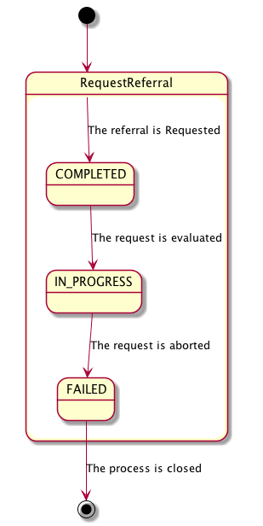

In the first case the Referral Requester wants to abort the process just created. The GP’s software, as Workflow Monitor, adds a new taskEvent to the Workflow Document, to evaluate the request, changing the status of the Request Referral task into status IN_PROGRESS. The Referral Requester in this situations can confirm the request, changing again the status into COMPLETED. If the GP decides to abort the process, a new taskEvent is added to the workflow document changing the status of the Request Referral task into FAILED.

The task Request Referral is characterized by:

* task status is “FAILED”
* the reference to the eReferral document and the Exception Report as outputs of the task

After updating the Workflow Monitor submits the newer version of the Workflow Document to the Document Repository/Registry. This eReferral process is closed (changing the workflowStatus of the Workflow document in status “CLOSED”)

**Bf. Failing of the scheduling process**

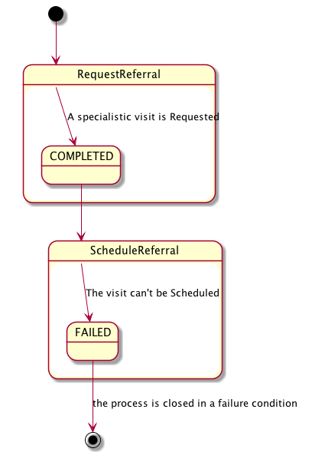

In the second case, the patient cannot schedule his specialist consultation, because there is some problem or inconsistency in the eReferral document. So in this phase the Hospital Information System, as Referral Scheduler, query and retrieve the eReferral Document and the Workflow Document related, to check the status of the eReferral and potential errors connected to the scheduling process. If the Referral Scheduler finds any problems, the scheduling phase fails and the eReferral Workflow is closed. The Workflow Monitor produces a report for the exception and updates the Workflow Document adding a new task named “Schedule Referral” which is characterized by:

* task status is “FAILED”
* the reference to the eReferral document as inputs of the task
* the reference to a report which contains reasons of the exception as outputs of the task

After updating the Workflow Monitor submits the newer version of the Workflow Document to the Document Repository/Registry. This event shall be notified to the Referral Requester. This eReferral process is closed (changing the workflowStatus of the Workflow document in status “CLOSED”) and, if necessary, another new process is started by the Referral Requester producing the second eReferral document and the second Workflow Document to track the new correct process. In this case the Workflow Document that tracks the second eReferral contains only one task named “Request Referral” which is characterized by:

* task status is “COMPLETED”
* as inputs of the task the references to:
* the Laboratory Report
* the reference to the workflow document that reflects the previous eReferral process failed
* the Exception Report
* the references to the eReferral document produced as outputs of the task.

For further technical details see Appendix B

**Cf. Failing of the reception phase**

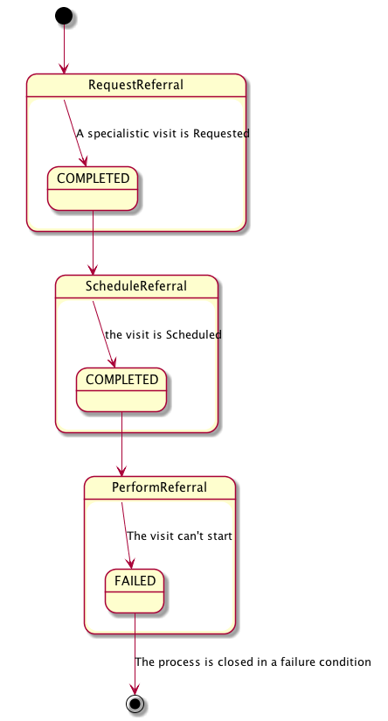

In the third case, when the Referral Performer checks the reservation of the patient he finds some problems, and cannot accept the patient for the consultation. In this case the Workflow Monitor updates the Workflow Document adding a new task named “Perform Referral” which is characterized by:

* task status “FAILED”
* the references to the eReferral produced by the GP as inputs of the task
* a report that describes the reason for the exception of the task as outputs of the task

The previous version of the Workflow Document is replaced by the new one. This event shall be notified to the Referral Requester. This eReferral process is closed (changing the workflowStatus of the WF document in status “CLOSED”) and, if necessary, another new process is started by the Referral Requester producing the second eReferral document and the second Workflow Document to track the new process. In this case the Workflow Document that tracks the second eReferral contains only one task named “Request Referral” which is characterized by:

* task status is “COMPLETED”
* as inputs of the task the references to:
* the Laboratory Report
* the reference to the workflow document that reflects the previous eReferral process failed
* the Exception Report
* the references to the eReferral document produced as outputs of the task

For further technical details see Appendix B

**Df. Failing of the visit**

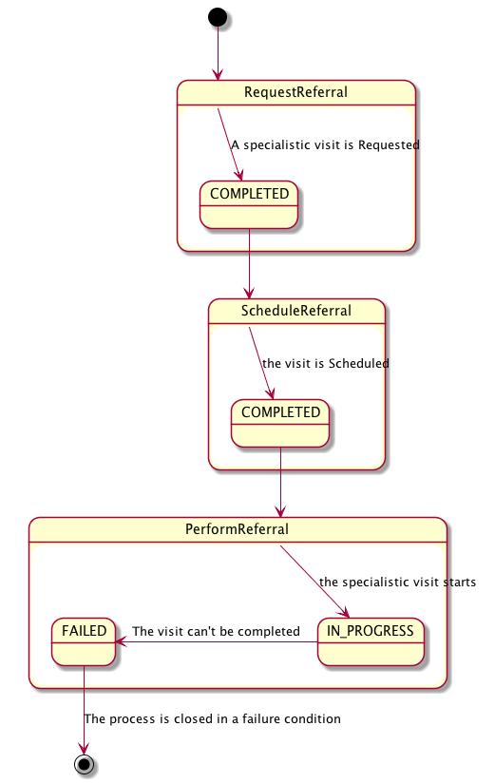

In the fourth case the patient is admitted to perform the visit but, once the specialist sees all the information related to the clinical process, he decides that the visit can’t be performed. In this case the Referral Performer updates the Workflow Document adding to the task named “Perform Referral” a new TaskEvent. At this moment the “Perform Referral” task is characterized by:

* task status “FAILED”
* the references to the eReferral document as inputs of the task
* the references to a report which contain reasons of the exception as outputs of the task

After updating the Workflow Monitor submits the newer version of the workflow Document to the Document Repository/Registry. This event shall be notified to the GP. This eReferral process is closed (changing the WorkflowStatus of the WF document in status “CLOSED”) and, if necessary, another new process starts producing the second eReferral document and the second Workflow Document to track the new correct process started by the Referral Requester. In this case the Workflow Document that tracks the second eReferral contains only one task named “Request Referral” which is characterized by:

* task status is “COMPLETED”
* as inputs of the task the references to:
* the Laboratory Report
* the reference to the workflow document that reflects the previous eReferral process failed
* the Exception Report
* the references to the eReferral document produced as outputs of the task

For further technical details see Appendix B

**BA. Scheduling cancellation process**

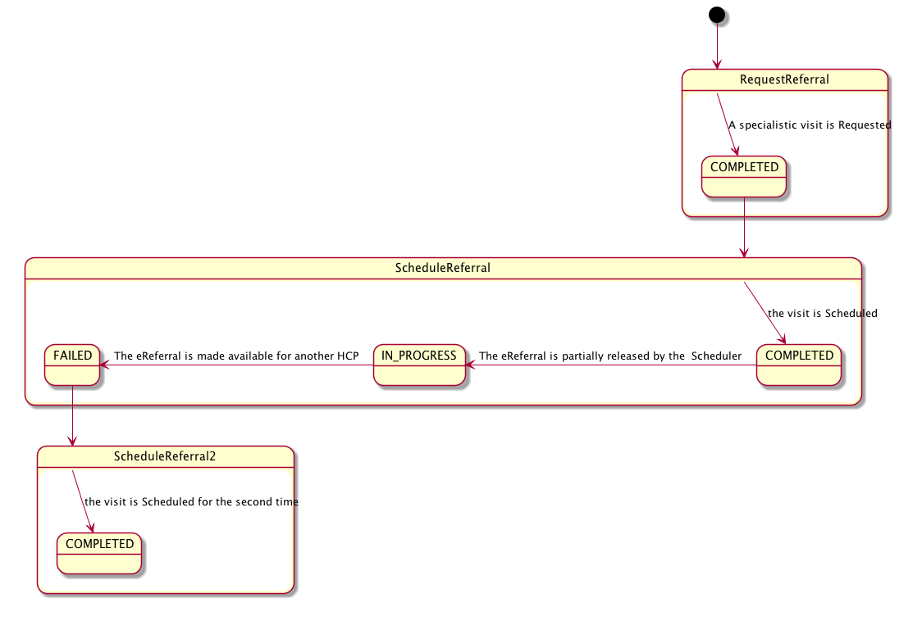

We can consider the situation in which it’s necessary to cancel the visit and make the eReferral available again for another scheduling step.

The Referral Scheduler queries and retrieves the Workflow Document to check the status of the eReferral document related. A visit has already been scheduled (Schedule Referral task in status=COMPLETED), so, in this situation, it isn’t possible to schedule another visit. The reception phase hasn’t already been performed but the eReferral process is still in-progress (WorkflowStatus of the Workflow Document “OPEN”). In this situation the Referral scheduler shall act on the Schedule Referral task, adding a new taskEvent to track the information that the eReferral document is released, in order to make it available for another scheduling phase. The task Schedule Referral is characterized by:

* a task status “IN_PROGRESS”

No inputs or outputs shall be added by this step. The eReferral document is now available to the same HCP to schedule the visit, changing the status of the task Schedule Referral into “COMPLETED”.

The task “Schedule Referral” is characterized by:

* a task status “COMPLETED”
* the references to the eReferral document produced by the GP as inputs of the task

If the patient choose another healthcare provider, before scheduling the visit for the second time it is necessary that the first healthcare provider, as Workflow Monitor, closes the Schedule Referral task adding a new taskEvent characterized by status “FAILED”. In this case the workflowStatus is still “OPEN”.

The Referral Performer that checks the status of the process retrieving the Workflow Document can find more than one Schedule Referral task, but only one in status COMPLETED (the others are in status=FAILED).

### X.3.2 Options

In this section we describe which variations from the normal process are allowed. It is mandatory for implementers to explicitly define which workflow options, if any, are addressed by their products (see section 4).

Options that may be selected for this Profile are listed below along with the Workflow Participants to which they apply.

This Workflow Definition Profile is intended to be combined with other IHE Profiles. These other profiles may have their specific options. These are not addressed in this section, which focuses only on the Options identified for this Workflow Definition Profile.

#### X.3.2.1 Process without Scheduling phase

The process can develop without a scheduling phase. This allows this profile to be implemented in many other real use-cases. If the “Process without Scheduling phase” option is chosen, rules to manage the process shall change.

If this workflow definition option is implemented the Referral Performer can start the visit while the eReferral process is in the Request Referral status. The scheduling phase is not needed, and the goal of the workflow is strictly related to create a process to give some specialistic clinical feedback to the Referral Requester.

These rule changes are addressed in the Task Specification section Y.3:

* Task “Request Referral”:
* Successors: Perform Referral
* Task “Schedule Referral”:
* Cardinality 0..0
* Task “Perform Referral”:
* Ancestors: Request Referral

#### X.3.2.2 Reminder Note Option

If this option is selected it is required that a Reminder Note is created as output of the task Schedule Referral.

## X.4 Workflow Definition Actors and Options

Workflow Participants introduced in Section X.3 are expected to be supported by Workflow Definition Actors that represents abstractions of IT systems. Compliance to this workflow definition profile and its options are based on selecting the implementation of one or more of these Workflow Definition Actors.

### X.4.1 Workflow Definition Actors

Table X.4.1-1 specifies the mapping of Workflow Participants to Workflow Definition Actors.

**Table X.4.1-1: XBeR-WD Workflow Participants grouping with Workflow Definition Actors**

| **Workflow Participant** | **Workflow Definition**  **Actor** |
| --- | --- |
| Referral Requester | Referral Requester Actor |
| Referral Scheduler | Referral Scheduler Actor |
| Referral Performer | Referral Performer Actor |
| Workflow Monitor | Workflow Monitor Actor |

### X.4.2 Workflow Options

Options that may be selected for this Profile are listed below along with the Workflow Definition Actors to which they apply. Although this Workflow Definition Profile is intended to be combined with other IHE Profiles, the specific options of these other Profiles are not addressed in this section, which focuses only on the Options identified for this Workflow Definition Profile.

Table X.4.2-1 specifies the options that are available, if any for each selected Workflow Actors.

Table X.4.2-1: XBeR Profile Workflow Definition Actors and Options

| XBeR-WD Workflow Definition Actor | option | Volume & Section |
| --- | --- | --- |
| Referral Requester actor | *No options selected* |  |
| Referral Scheduler actor | *Reminder Note Option* | PCC TF-1: X.3.2.2 |
| Referral Performer actor | *Process without Scheduling Phase Option* | PCC TF-1: X.3.2.1 |
| Workflow Monitor actor | *No options selected* | - |

### X.4.3 Workflow Definition Profile Grouping with other Profiles

This Workflow Definition Profile is intended to be combined with other IHE Profiles. The profiles that are candidates for such combinations and the associated rules are specified in this Section.

Figure X.4.3-1 presents an overview for the major classes of IHE Profiles that shall or may be grouped:

* The Workflow Definition Profile SHALL be grouped with the XDW Profile.
* The Workflow Definition Profile SHOULD be grouped with one or more Document Content Profiles matched to the input and output reference “Document Labels” in the Workflow Definition Profile (Defined in Vol.2). The Workflow Definition Profile provides only “Document Labels” for these input and output reference documents and not the actual specifications. This selection of the actual document content specification (IHE Content profiles or others), need to be made by the environment that deploys the Workflow Definition Profile.
* The Workflow Definition Profile, the XDW Profile and the selected Document Content Profiles shall be grouped as decided by the deployment environment, with the suitable Integration Profile supporting a document transport service such as XDS for Document Sharing, XDR/XDM for point-to-point directed transport, or other functionally equivalent profiles.

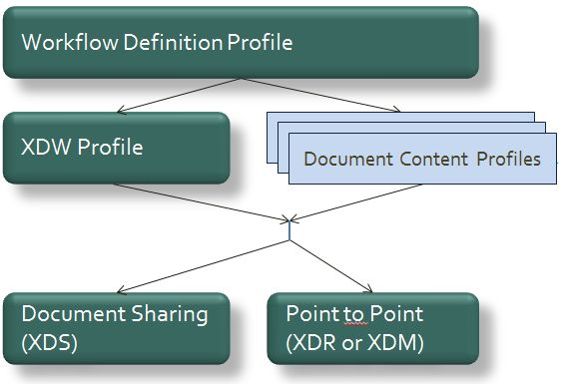

**Figure X.4.3-1: Grouping of profiles**

The grouping of XDW actors with each of the XBeR-WD workflow definition actors is specified in table X.4.3-1. These XDW Actors support the creation, consumption and update of the XDW workflow document which is the shared data structure which is tracking the evolution of the workflow. This allows the XBeR-WD workflow definition actors, at any point in the workflow to access the most current status of the workflow and share the tasks performed with all other workflow definition actors.

Note: See IHE ITI TF-1: Section 30.3 (XDW Supplement) for other groupings that are needed for the XDW Actors to permit sharing of a Workflow Document with IHE XDS, XDR or XDM Profiles.

Table X.4.3-1: XBeR-WD workflow definition actors grouping with XDW Profile Actors

Table X.4.3-1: XBeR-WD Workflow Definition Actors grouping with XDW Actors

| Workflow Definition  Actor | Shall be grouped with: |
| --- | --- |
| Referral Requester actor | XDW Content Creator  XDW Content Consumer  XDW Content Updater |
| Referral Scheduler actor | XDW Content Updater  XDW Content Consumer |
| Referral Performer actor | XDW Content Updater  XDW Content Consumer |
| Workflow Monitor actor | XDW Content Updater  XDW Content Consumer |

## X.5 Security Considerations

For this section please refer to the section ITI TF-1: 30.5.

Volume 2 – Content Modules

## Y.1 XBeR Workflow Definition - XDW Workflow Document – Common Attributes

This workflow definition profile is assigned a specific OID that shall be used to assign an identifier to the workflowDefinitionReference element of a Workflow Document that tracks an eReferral process.

|  |  |
| --- | --- |
| type of Workflow | Workflow Definition Reference |
| eReferral workflow | 1.3.6.1.4.1.19376.1.5.3.1.5.1 |

The XBeR-WD Workflow Definition does not introduce new metadata and all the metadata elements used are the common XDS document metadata specified in ITI TF-3:4.1.5 and in ITI TF-3:5.4.6. In this section only the use of some specific metadata for the use of XDW in the XBeR-WD context is specified.

| XDS Metadata Attribute | Definition |
| --- | --- |
| typeCode | For the Workflow Document which tracks the XBeR-WD process the code for the typeCode shall be:  This code will be assigned by LOINC |
| classCode | For the Workflow Document which tracks the XBeR-WD process the code for the classCode is defined by the XDW profile.  See XDW Supplement Section 5.4.6.1. |
| eventCodeList | **Rule 1:**  An XBeR-WD workflow shall be created with code OPEN and shall remain in this status until it is set to CLOSED.  **Rule 2:**  An XBeR-WD workflow should be set to CLOSED when:  - one of the tasks has the status FAILED (except for the scheduling cancellation process where the FAILED status of the Schedule Referral task is preceded by the status IN PROGRESS. In this case the workflowStatus is still open after the task fails);  or  - when you complete the workflow with the Perform Referral task in status COMPLETED.  See ITI TF-3: 5.4.5.7 for a general description of this attribute. |
| serviceStartTime | It is the time at which work began on the first task for this workflow. |
| serviceStopTime | It is the time at which the status of the overall Workflow is changed from OPEN to CLOSED.  It shall be empty when the workflow is still in OPEN state. |

## Y.2 XDW Content Modules

The main instrument of the Cross-enterprise Basic eReferral Workflow Definition Profile is the Workflow Document defined in the XDW Profile. This document does not include clinical information about the patient directly. It shall only contain information necessary for organizing and defining work tasks. All clinical information regarding any task shall be provided through separate documents that are referenced from the associated input or output documents. Detailed knowledge of the Cross-enterprise Document Workflow (XDW) profile is indispensable in understanding the following sections. For more details, refer to ITI TF-3: 5.4.

## Y.3 Tasks Specifications

Workflow Description Overview:

|  |  |  |  |  |  |  |  |
| --- | --- | --- | --- | --- | --- | --- | --- |
| Task Type | Requi-rement  For task initiation | Task Statuses  *valid when task initiated | Task  Property | Input Docs | Opt | Output Docs | Option |
| Request Referral | At XDW doc creation | COMPLETED*  IN_PROGRESS  FAILED | Cardinality: 1..1  Removable: no | ClinicalInput | O | eReferral | R |
| ExceptionReport | C: (If the request is aborted just created) |
| Schedule Referral | When Request Referral is COMPLETED, or Schedule Referral is FAILED (in case of scheduling cancellation) | COMPLETED*  IN_PROGRESS  FAILED* | Cardinality: 1..n  Removable: no  * These may change if Workflow Options are selected | eReferral | R | ExceptionReport | C: (If the visit can’t be scheduled) |
| ReminderNote | O * This may change if Workflow Options are selected |
| Perform Referral | When Schedule Referral is COMPLETED | IN_PROGRESS*  COMPLETED  FAILED* | Cardinality: 1..1  Removable: no | eReferral | R | ExceptionReport | C: (if task status is failed) |
| ClinicalReportOfTheVisit | R |

In the next sections we define rules and constraints defined for the creation and update of the XDW Workflow Document related to the eReferral process.

The set of rules defined here is necessary to manage transition between tasks. For each task are defined:

* The task attributes: ID, name, type description;
* The sequence of the tasks: the previous and the next task;
* Which Workflow Participant is allowed to create each task and to change the status;
* The task event;
* The input and output documents.

The rules in the workflow definition ensure that the different participants in a workflow operate jointly to advance within tasks and to move from one task to another in a consistent way.

### Y.3.1 Task: “Request Referral”

| Task attributes | Rules for the task “Request Referral” |
| --- | --- |
| Task id | Unique id of the instance of the task |
| Task type | **Request Referral** |
| Task name | RequestReferral |
| Task description | A Referral process is requested for a patient by the Referral Requester |
| Task dependencies | Ancestors: none  Successors: Schedule Referral  * These may change if Workflow Options are selected |
| Status allowed | **COMPLETED**: An Ordering task is always set to COMPLETED when confirmed or just created.  **IN_PROGRESS**: If the request have to be evaluated  **FAILED**: If the Referral Requester wants to abort the process just created |
| Status transactions (*) | |  |  |  | | --- | --- | --- | | **Initial Status** | **Final Status** | **eventType** | | none | COMPLETED | create | | COMPLETED | IN_PROGRESS | release | | IN_PROGRESS | FAILED | fail | | IN_PROGRESS | COMPLETED | complete |   If the request has to be evaluated there is a transaction of status from COMPLETED to IN_PROGRESS. If the request is confirmed there is a transaction of status from IN_PROGRESS to COMPLETED. If the request is aborted there is a transaction of status from IN_PROGRESS to FAILED. |
| Input | Optional  ClinicalInput |
| Output | * Required   + eReferral: if the status is completed   + ExceptionReport: if the status is FAILED |
| Owner | Referral Requester or Workflow Monitor |
| Owner changes | No |
| <taskEvent> | 1 if the request is not evaluated after creation.  3 in other cases. |
| Task Removal allowed | No |
| Task duplication | No |

(*) The element eventType stores the type of event that produces the change in the task status. In the “Status transactions” we want to associate the specific type of event to the status transaction produced. For further details on eventType element see XDW profile.

### Y.3.2 Task: “Schedule Referral”

| **Task attributes** | **Rules for the task “Schedule Referral”** |
| --- | --- |
| Task id | Unique id of the instance of the task |
| Task type | **Schedule Referral** |
| Task name | ScheduleReferral <i> |
| Task description | An appointment is scheduled by the Referral Scheduler chosen by the patient |
| Task dependencies | Ancestors: Request Referral in status COMPLETED or Schedule Referral in status FAILED  Successors: Schedule Referral, Perform Referral |
| Status allowed | **COMPLETED:** if the appointment is scheduled  **IN_PROGRESS:** if the visit is released by the HCP  **FAILED:** if the appointment can’t be scheduled or cancelled. |
| Status transactions | If the appointment of the patient is cancelled, it shall be a transaction of status from COMPLETED to IN_PROGRESS. If the visit is scheduled again by the same HCP the status changes from IN_PROGRESS to COMPLETED. If another HCP is expected to schedule the visit the status shall change from IN_PROGRESS to FAILED   |  |  |  | | --- | --- | --- | | **Initial Status** | **Final Status** | **eventType** | | none | COMPLETED | create | | none | FAILED | fail | | COMPLETED | IN_PROGRESS | release | | IN_PROGRESS | COMPLETED | claim | | IN_PROGRESS | FAILED | expire | |
| Input | * Required   + eReferral |
| Output | * Required   + ExceptionReport: If the visit can’t be scheduled * Optional   + Reminder Note   * These may change if Workflow Options are selected |
| Owner | Referral Scheduler or Workflow Monitor |
| owner changes | Yes, in case of cancellation of the appointment |
| <taskEvent> | Only One if the appointment isn’t cancelled, two if the eReferral is released, three if the visit scheduled by the specific HCP is completely cancelled. |
| Task Removal allowed | No |
| Task duplication | Yes |

### Y.3.3 Task: “Perform Referral”

| Task attributes | Rules for the task “Perform Referral” |
| --- | --- |
| Task id | Unique id of the instance of the task |
| Task type | **Perform Referral** |
| Task name | PerformReferral |
| Task description | A specialist consultation is started and performed by the Referral Performer |
| Task dependencies | Ancestors: Schedule Referral (in status COMPLETED)  * These may change if Workflow Options are selected  Successors: none |
| Status allowed | **IN_PROGRESS:** if the patient can be admitted  **COMPLETED:** if the visit is completed producing a Report    **FAILED:** if the visit can’t be completed |
| Status transactions | The task born IN_PROGRESS and it shall be a transaction of status into status COMPLETED when the visit is completed with a Report, or into status FAILED when the visit can’t be completed.   |  |  |  | | --- | --- | --- | | **Initial Status** | **Final Status** | **eventType** | | none | IN_PROGRESS | create | | IN_PROGRESS | COMPLETED | complete | | none | FAILED | fail | | IN_PROGRESS | FAILED | fail | |
| Input | * Required   + eReferral |
| Output | * Required   + ClinicalReportOfTheVisit: if the visit is completed   + ExceptionReport: if the visit fails |
| Owner | Referral Performer or Workflow Monitor |
| owner changes | no |
| <taskEvent> | Only one (failed): if the patient can’t be admitted in the healthcare structure  Two in the other cases |
| Task Removal allowed | No |
| Task duplication | No |

## Y.4 Input and output documents

The WS-HumanTask element that permits to store the reference of an object in input or output sections is described in IHE ITI TF-3:5.4.3

In table Y.4-1 we define the kind of document involved in the eReferral process. For each type of document this table defines the Documents Labels of the document. This Label describes the function or the role that the document performs in the course of the process or during the execution of a task, and defines the type of information conveyed and expected by the owner of the tasks.

Table Y.4-1: Documents involved in the eReferral process

|  |  |
| --- | --- |
| Document Label | Example of content profile |
| **eReferral** | XDS-SD |
| **ClinicalReportOfTheVisit** | XDS-SD  EDR  PPOC  XD-LAB  ECDR  CIRC  DRPT  APSR |
| **ExceptionReport** | XDS-SD |
| **ClinicalInput** | XDS-SD  PPOC  XD-LAB  ECDR  CIRC  DRPT  APSR |
| **ReminderNote** | XDS-SD |

Appendix A - Complete example of eReferral Workflow Document

In this Appendix we propose a complete example of a Workflow Document related to the eReferral process as we can see it when the visit is completed successfully.

|  |
| --- |
| <?xml version="1.0" encoding="UTF-8"?>  <ns3:XDW.WorkflowDocument  xmlns:ns1="urn:hl7-org:v3"  xmlns:ns2="http://docs.oasis-open.org/ns/bpel4people/ws-humantask/types/200803"  xmlns:ns3="urn:ihe:iti:2011:xdw"  xmlns:xsi="http://www.w3.org/2001/XMLSchema-instance"  xsi:schemaLocation="urn:ihe:iti:2011:xdw file:C: XDW-2011-09-13.xsd">  <ns3:id root="1.2.3.4.5"/>  <ns3:effectiveTime value="20110401031520"/>  <ns3:confidentialityCode code="1.24.3.3.3"/>  <ns3:patient>  <ns3:id root="1.3.6.1.4.1.21367.13.20.1000" extension="33333"  assigningAuthorityName="IHERED"/>  </ns3:patient>  <ns3:author>  <ns3:assignedAuthor>  <ns1:id root="1.2.3.4.5" extension="11111"/>  <ns1:assignedPerson>  <ns1:name>  <ns1:family>Brum</ns1:family>  <ns1:prefix>Dr.</ns1:prefix>  </ns1:name>  </ns1:assignedPerson>  </ns3:assignedAuthor>  </ns3:author>  <ns3:workflowInstanceID>urn:oid:1.2.3.4</ns3:workflowInstanceID>  <ns3:workflowDocumentSequenceNumber>3</ns3:workflowDocumentSequenceNumber>  <ns3:workflowStatus>CLOSED</ns3:workflowStatus>  <ns3:workflowStatusHistory>  <ns3:documentEvent>  <ns3:eventTime>2006-05-04T18:13:51.0Z</ns2:eventTime>  <ns3:eventType>create</ns2:eventType>  <ns3:taskEventIdentifier>urn:oid:1.1.1.1.4</ns2:taskEventIdentifier>  <ns3:author>Mr. Rossi</ns2:author >  <ns3:previousStatus></ns2:previousStatus>  <ns3:actualStatus>OPEN</ns2:actualStatus>  </ns3:documentEvent>  <ns3:documentEvent>  <ns3:eventTime>2006-05-07T09:53:45.0Z</ns2:eventTime>  <ns3:eventType>complete</ns2:eventType>  <ns3:taskEventIdentifier>urn:oid:1.1.1.1.7</ns2:taskEventIdentifier>  <ns3:author>Dr. Brum</ns2:author >  <ns3:previousStatus>OPEN</ns2:previousStatus>  <ns3:actualStatus>CLOSED</ns2:actualStatus>  </ns3:documentEvent>  </ns3:workflowStatusHistory>  <ns3:workflowDefinitionReference>urn:oid:1.2.3.4.5.6.7.8.9</ns3:workflowDefinitionReference>  <ns3:TaskList>  <ns3:XDWTask>  <ns3:taskData>  <ns3:taskDetails>  <ns2:id>urn:oid:1.1.1.1.1</ns2:id>  <ns2:taskType>Request Referral</ns2:taskType>  <ns2:name>RequestReferral</ns2:name>  <ns2:status>COMPLETED</ns2:status>  <ns2:createdTime>2006-05-04T18:13:51.0Z</ns2:createdTime>  <ns2:lastModifiedTime>2006-05-04T18:13:51.0Z</ns2:lastModifiedTime>  <ns2:renderingMethodExists>false</ns2:renderingMethodExists>  <ns2:actualOwner>Dr. Rossi</ns2:actualOwner>  <ns2:createdBy>Dr. Rossi</ns2createdBy>  </ns3:taskDetails>  <ns2:description>code for the type of visit requested</ns2:description>  <ns2:input>  <ns2:part name="ClinicalInput">  <reference uid="urn:oid:1.2.3.4.4.3.2.2.3" home="urn:oid:1.2.3"/>  </ns2:part>  </ns2:input>  <ns2:output>  <ns2:part name="eReferral">  <reference uid="urn:oid:1.2.3.4.4.4" home="urn:oid:1.2.3"/> </ns2:part>  </ns2:output>  </ns3:taskData>  <ns3:taskEventHistory>  <ns3:taskEvent>  <ns3:id>1</ns3:id>  <ns3:eventTime>2006-05-04T18:13:51.0Z</ns3:eventTime>  <ns3:identifier>urn:oid:1.1.1.1.1</ns3:identifier>  <ns3:eventType>create</ns3:eventType>  <ns3:status>COMPLETED</ns3:status>  </ns3:taskEvent>  </ns3:taskEventHistory>  </ns3:XDWTask>  <ns3:XDWTask>  <ns3:taskData>  <ns3:taskDetails>  <ns2:id>urn:oid:1.1.1.1.1</ns2:id>  <ns2:taskType>Schedule Referral</ns2:taskType>  <ns2:name>ScheduleReferral</ns2:name>  <ns2:status>COMPLETED</ns2:status>  <ns2:createdTime>2006-05-05T08:53:45.0Z</ns2:createdTime>  <ns2:lastModifiedTime>2006-05-05T08:53:45.0Z</ns2:lastModifiedTime>  <ns2:renderingMethodExists>false</ns2:renderingMethodExists>  <ns2:actualOwner>HIS</ns2:actualOwner>  <ns2:createdBy>HIS</ns2:createdBy>  </ns3:taskDetails>  <ns3:description>code for the type of visit booked and visit info</ns3:description>  <ns2:input>  <ns2:part name="eReferral">  <reference uid="urn:oid:1.2.3.4.4.3.2.2.3" home="urn:oid:1.2.3"/> </ns2:part>  </ns2:input>  </ns3:taskData>  <ns3:taskEventHistory>  <ns3:taskEvent>  <ns3:id>1</ns3:id>  <ns3:eventTime>2006-05-05T08:53:45.0Z</ns3:eventTime>  <ns3:identifier>urn:oid:1.1.1.1.1</ns3:identifier>  <ns3:eventType>create</ns3:eventType>  <ns3:status>COMPLETED</ns3:status>  </ns3:taskEvent>  </ns3:taskEventHistory>  </ns3:XDWTask>  <ns3:XDWTask>  <ns3:taskData>  <ns3:taskDetails>  <ns2:id>urn:oid:1.1.1.1.1</ns2:id>  <ns2:taskType>Perform Referral</ns2:taskType>  <ns2:name>PerformReferral</ns2:name>  <ns2:status>COMPLETED</ns2:status>  <ns2:createdTime>2006-05-07T08:50:00.0Z</ns2:createdTime>  <ns2:lastModifiedTime>2006-05-07T09:53:45.0Z</ns2:lastModifiedTime>  <ns2:renderingMethodExists>false</ns2:renderingMethodExists>  <ns2:actualOwner>Dr. Brum</ns2:actualOwner>  <ns2:createdBy>HIS</ns2:createdBy>  </ns3:taskDetails>  <ns3:description>code for the type of visit</ns3:description>  <ns2:input>  <ns2:part name="eReferral">  <reference uid="urn:oid:1.2.3.4.4.3.2.2.3" home="urn:oid:1.2.3"/>  </ns2:part>  </ns2:input>  <ns2:output>  <ns2:part name="ClinicalReportOfTheVisit">  <reference uid="urn:oid:1.2.3.4.4.4" home="urn:oid:1.2.3"/> </ns2:part>  </ns2:output>  </ns3:taskData>  <ns3:taskEventHistory>  <ns3:taskEvent>  <ns3:id>1</ns3:id>  <ns3:eventTime>2006-05-07T08:50:00.0Z</ns3:eventTime>  <ns3:identifier>urn:oid:1.1.1.1.1</ns3:identifier>  <ns3:eventType>create</ns3:eventType>  <ns3:status>IN_PROGRESS</ns3:status>  <ns3:startOwner>HIS</ns3:startOwner>  <ns3:endOwner>Dr. Brum</ns3:endOwner>  </ns3:taskEvent>  <ns3:taskEvent>  <ns3:id>2</ns3:id>  <ns3:eventTime>2006-05-07T09:53:45.0Z</ns3:eventTime>  <ns3:identifier>urn:oid:1.1.1.1.1</ns3:identifier>  <ns3:eventType>create</ns3:eventType>  <ns3:status>COMPLETED</ns3:status>  </ns3:taskEvent>  </ns3:taskEventHistory>  </ns3:XDWTask>  </ns3:TaskList>  </ns3:XDW.WorkflowDocument> |

Appendix B - Technical development of WD related to the eReferral process

In this Appendix we present more technical information related to the use-case scenario described in Volume 1 of this profile.

B.1 Management of the “Failing of Scheduling”



Figure B.1-1: Management of the workflow document: scheduling failing

B.2 Management of the “Failing of the reception” phase

Figure B.2-1: Management of the workflow document: reception failing

B.3 Management of the “Failing of the visit”



Figure B.3-1: Management of the workflow document: referring failing